Objectives:

* Writing and reading files
* Try and catch statement
* Intro to GUI Interfaces

**There are 4 print screens, each worth 25%**

**Project #1** (Based on Chapter 6 Files and Exceptions)



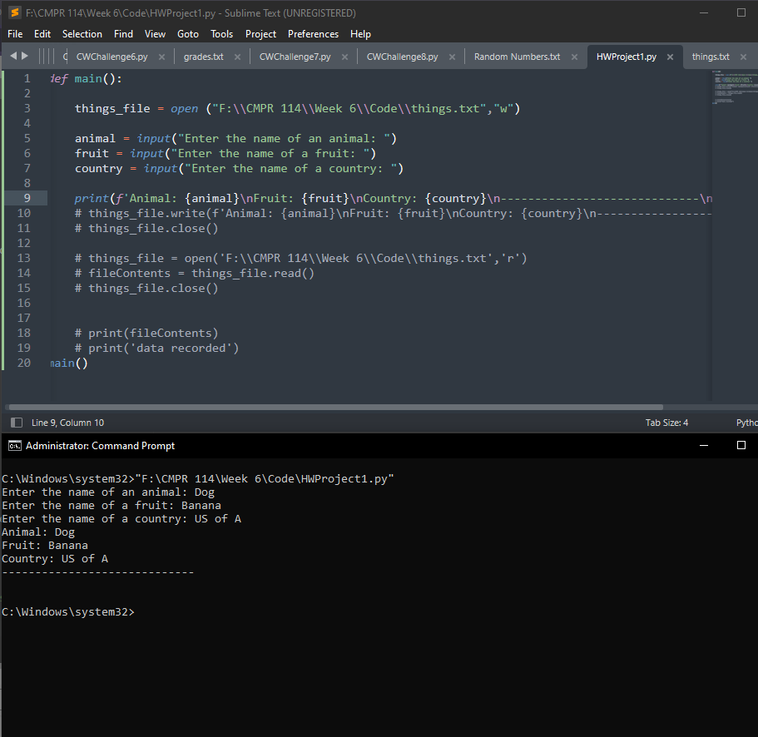

def main():

things_file = open ("F:\\CMPR 114\\Week 6\\Code\\things.txt","w")

animal = input("Enter the name of an animal: ")

fruit = input("Enter the name of a fruit: ")

country = input("Enter the name of a country: ")

print(f'Animal: {animal}\nFruit: {fruit}\nCountry: {country}\n-----------------------------\n')

# things_file.write(f'Animal: {animal}\nFruit: {fruit}\nCountry: {country}\n-----------------------------\n')

# things_file.close()

# things_file = open('F:\\CMPR 114\\Week 6\\Code\\things.txt','r')

# fileContents = things_file.read()

# things_file.close()

# print(fileContents)

# print('data recorded')

main()

**#1 print screen the output with code below here**



**#2 print screen the output with code below here**

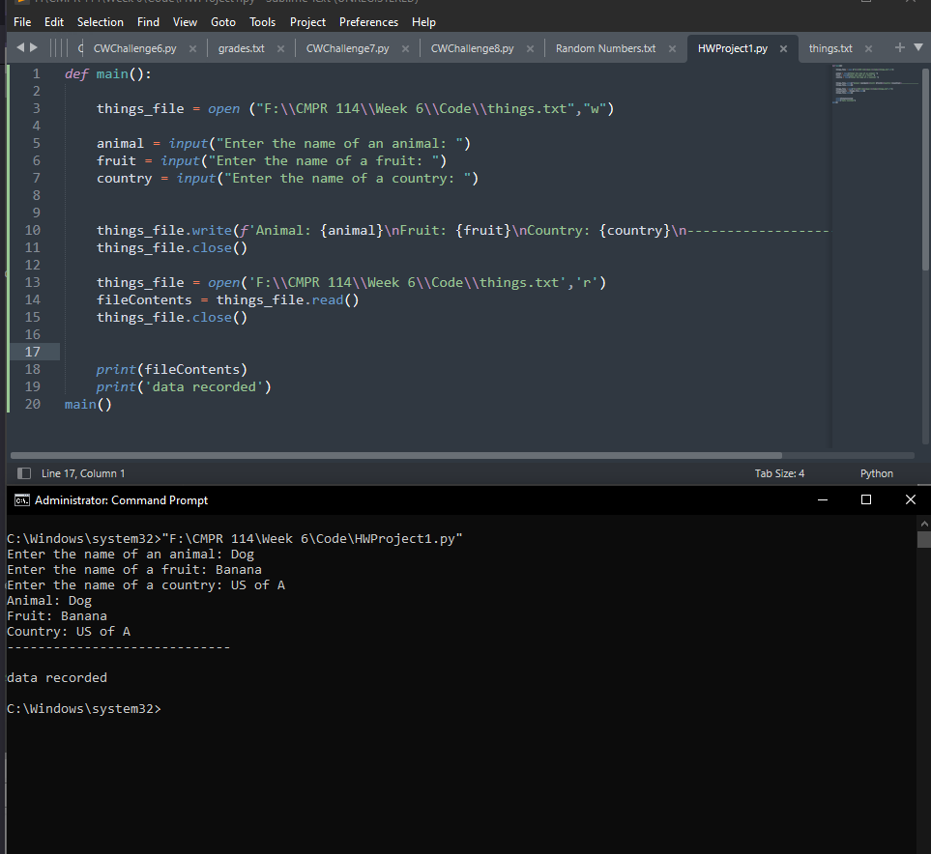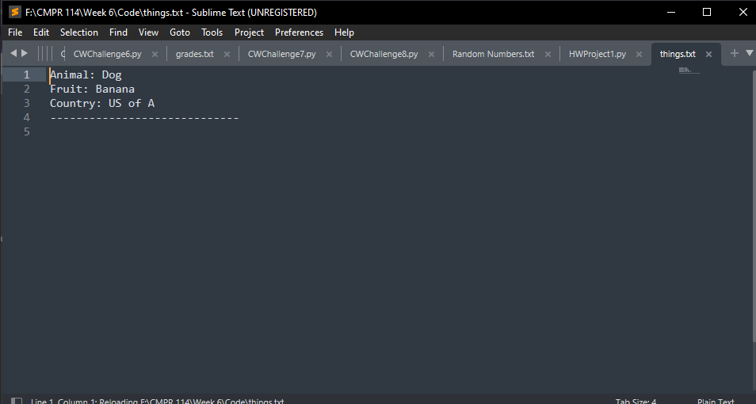

def main():

things_file = open ("F:\\CMPR 114\\Week 6\\Code\\things.txt","w")

animal = input("Enter the name of an animal: ")

fruit = input("Enter the name of a fruit: ")

country = input("Enter the name of a country: ")

things_file.write(f'Animal: {animal}\nFruit: {fruit}\nCountry: {country}\n-----------------------------\n')

things_file.close()

things_file = open('F:\\CMPR 114\\Week 6\\Code\\things.txt','r')

fileContents = things_file.read()

things_file.close()

print(fileContents)

print('data recorded')

main()

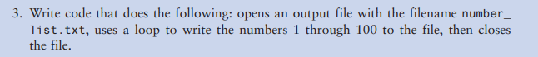

**#3 print screen the output with code below here**

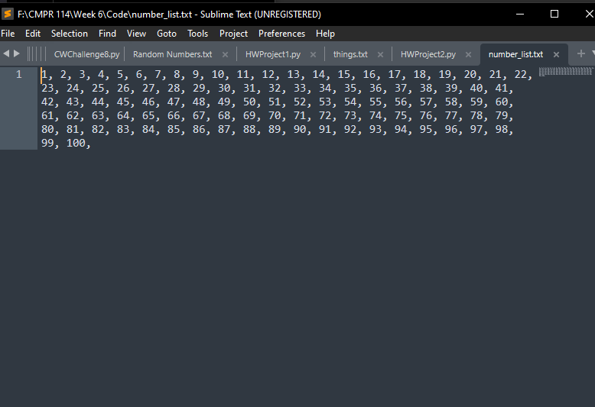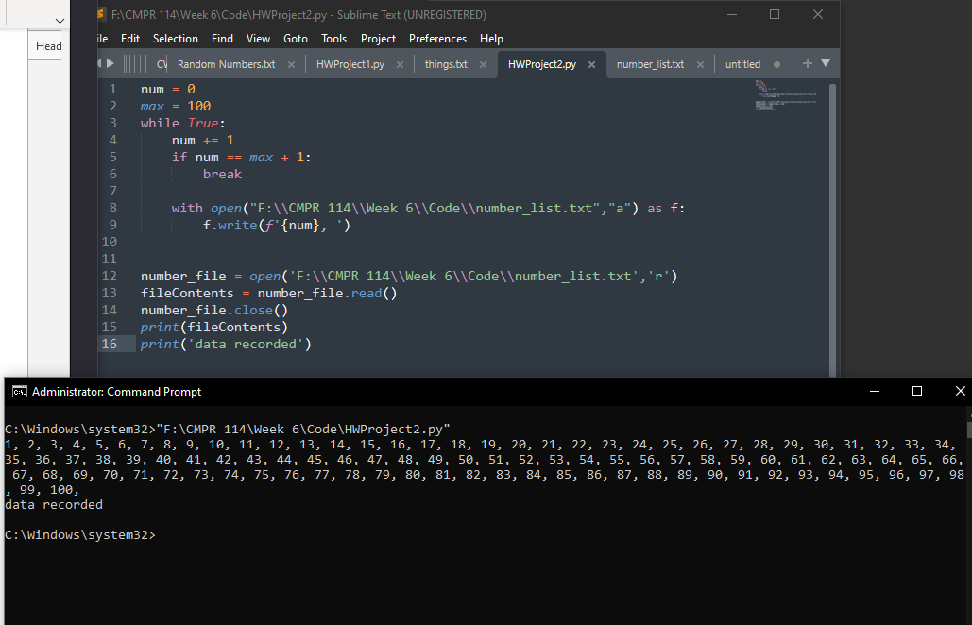

**Project #2 (**Create a **GUI** application for the following below)

Be sure to create a GUI application using Tkinter

Use the following numbers inside a text file

100-1000

Example

100

200

300

**#4 print screen the output with code below here**

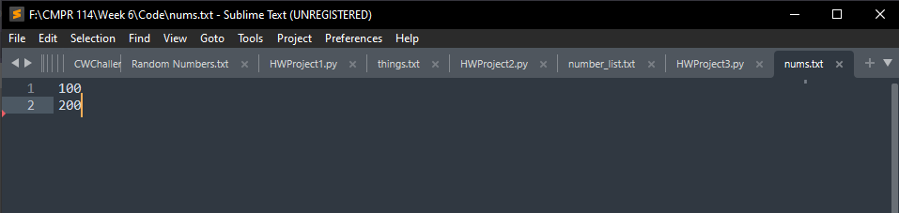

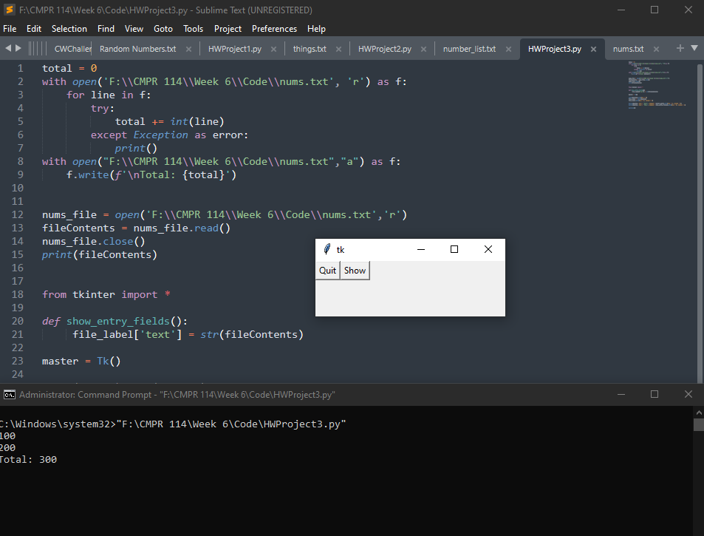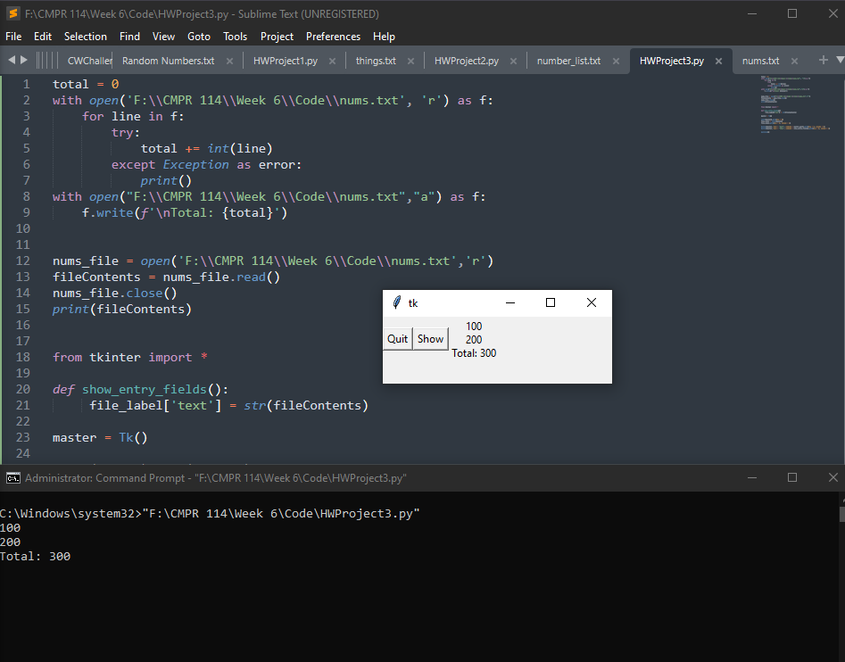

total = 0

with open('F:\\CMPR 114\\Week 6\\Code\\nums.txt', 'r') as f:

for line in f:

try:

total += int(line)

except Exception as error:

print()

with open("F:\\CMPR 114\\Week 6\\Code\\nums.txt","a") as f:

f.write(f'\nTotal: {total}')

nums_file = open('F:\\CMPR 114\\Week 6\\Code\\nums.txt','r')

fileContents = nums_file.read()

nums_file.close()

print(fileContents)

from tkinter import *

def show_entry_fields():

file_label['text'] = str(fileContents)

master = Tk()

Label(master).grid(row = 0)

file_label = Label(master)

file_label.grid(row = 0, column = 2)

Button(master, text = 'Quit', command = master.quit).grid(row = 0, column = 0)

Button(master, text = 'Show', command = show_entry_fields).grid(row = 0, column = 1)

mainloop()

**Submit this document to Module 6 homework**